**Claire Wineland-**

[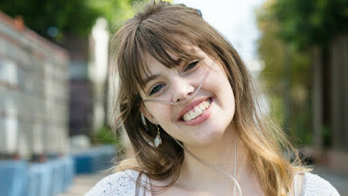](https://4.bp.blogspot.com/-PYjF_mFNJr8/W8rEyJOL3sI/AAAAAAAAAWI/YOWVSuofaaEFZ4nZ6sYeTlww3UbfTVzGQCEwYBhgL/s1600/wineland-aarc-congress-keynote-17-1%2B%25281%2529.jpg)

Who was born with a disease which has no cure. But [ClaireWineland](https://en.wikipedia.org/wiki/Claire_Wineland) knew that was not the end of her world. She was an activist and author. Her these works were about her life. About how she suffered from this disease. She was born with this disease and was in a coma at the age of **13 for sixteen days**. With the chance of living **1%**. But she never gave up. That was time who gave up on her. She died in the age of **21** on **September 2, 2018**. There was no cure for her. The name is the disease is **Cystic fibrosis**.

[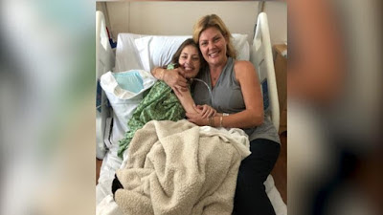](https://1.bp.blogspot.com/-N12xs8-KJzY/W8rFUwA51SI/AAAAAAAAAWQ/njBrvDeMAIYQYpUZIK0-cvatN4ER_lNuACEwYBhgL/s1600/180827202532-claire-wineland-vid-thumb-2-exlarge-169.jpg)

**Cystic Fibrosis:**

Cystic fibrosis (CF) is a severe, genetic syndrome that causes determined lung toxicities and increasingly bounds the capability to take breaths. It is a chromosomal syndrome driven by [CFTR](https://en.wikipedia.org/wiki/Cystic_fibrosis_transmembrane_conductance_regulator) transformations that disturb the [exocrine glands](https://en.wikipedia.org/wiki/Exocrine_gland). Establishing with unreasonably viscous mucus creation, patients naturally experience obstacle of passageways. Lung disease is blameable for the common of illness in patients.

**Diagnose:**

[](https://2.bp.blogspot.com/-Edbs5rY_MBc/W8rFwJUCQjI/AAAAAAAAAWY/9mNPQZeD2KQ4RfwxUona9BvlgEaEDuQ0QCEwYBhgL/s1600/61116271_s-e1525174130736.jpg)

**There are two experiments commonly used to identify cystic fibrosis.**

* While the widely held of identifies are made by [sweat test](https://en.wikipedia.org/wiki/Sweat_test), around a third are merely confirmed throughout babyhood or much later in life. Cystic fibrosis is inherited from paternities who are transporters of the faulty gene, and couples can be selected to see if their kid could be at risk.
* A sweat test, which processes the quantity of chloride in sweat, and a genomic test, which identifies chromosomal transformations related with the illness. Because of the brutality of CF and the need for practical treatment, newborns are regularly screened.

**Cystic fibrosis symptoms:**

[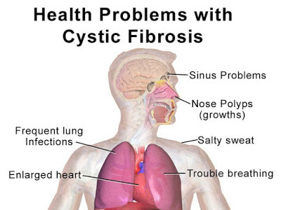](https://2.bp.blogspot.com/-1prMBJRFB1A/W8rGarya8CI/AAAAAAAAAWg/ACGji9lf1sQdj021JQIegm8PSkBo-ZxRQCEwYBhgL/s1600/Blausen_CysticFibrosis%2B%2528copy%2529.jpeg)

* These signs are believed to be due to faulty protein consumption  minor to trypsin and chymotrypsin insufficiency and are seen most regularly in new-borns fed.
* [Oedema](https://en.wikipedia.org/wiki/Edema), [Hypoproteinemia](https://en.wikipedia.org/wiki/Hypoproteinemia), and [Anemia](https://en.wikipedia.org/wiki/Anemia) may be the presenting signs in young babies with cystic fibrosis (CF) of the pancreas.
* Either one a soybean formula that holds a trypsin inhibitor, or human milk that has a poorer protein content than most commercial plans.

**Cystic fibrosis treatments:**

[](https://1.bp.blogspot.com/-BYiRWIbTpwQ/W8rGu24EkaI/AAAAAAAAAWo/b2ot9oChp8c_nZSOBO5IeiN9_9ID0_MSACLcBGAs/s1600/download.png)

* There is no treatment for cystic fibrosis but there are healings and remedies that make it calmer to live with the situation.
* Mucus-thinning remedies may be administered.
* Careful nursing is mandatory to identify lung contagions.
* Although these methods have not yet been effective at treating cystic fibrosis it is an electrifying area of investigation.
* [Gene Therapy](https://en.wikipedia.org/wiki/Gene_therapy) targets to repair faulty CFTR genes or swap them with with working copies.